Airbnb project review. 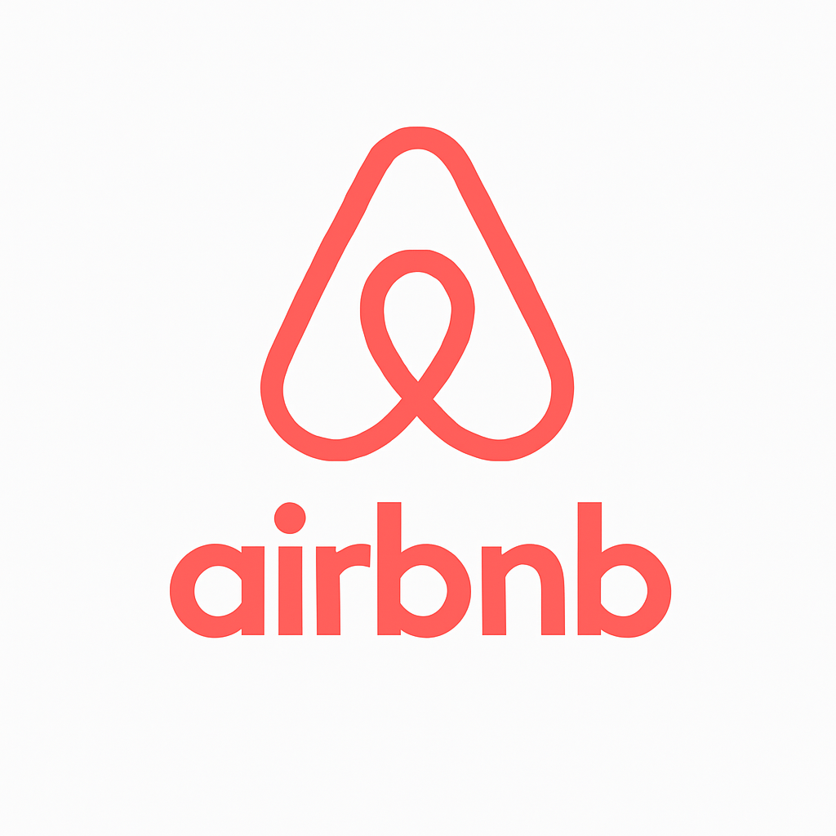

### Key Business Insights for Airbnb Strategy Development

**1. High Performing Hosts**

* **Host: Maya**
  + **Reviews:** 2,273 (indicates strong guest engagement and possible customer satisfaction)
  + **Opportunity:** Maya can be approached for promotional collaborations, referral programs, or premium host recognition to influence and uplift other hosts.
* **Hosts: Yesu & Akiko**
  + **Combined Reviews:** 1,971
  + **Opportunity:** These hosts are consistently engaged. Airbnb can create case studies or success stories to mentor newer or underperforming hosts.

**2. Top Booking Areas**

* **Manhattan:** 21.6K bookings (Highest)
* **Brooklyn:** 20.1K bookings (Second Highest)
  + **Opportunity:**
    - Focus marketing, seasonal promotions, and experience packages in **Manhattan** and **Brooklyn**.
    - Enhance infrastructure support (e.g., local experiences, host tools, and dynamic pricing recommendations).

**3. Neighborhood-Level Insights & Premium Pricing Areas**

* **Staten Island:**
  + **Fort Wadsworth:** Avg. price $800
  + **Woodrow:** Avg. price $700
  + **Room Types Price Range:** $57 – $174
  + **Insight:** Despite limited booking data, these areas show premium pricing potential.
  + **Opportunity:** Target luxury travel segments (weddings, retreats, etc.) and promote high-end amenities.
* **Brooklyn:**
  + **Seagate:** Highest avg. price $487.86
  + **Room Types Price Range:** $50 – $177
  + **Opportunity:** Promote Seagate as a luxury destination within Brooklyn with curated listings and feature-rich property support.

**4. Underserved Markets**

* **Queens:**
  + Only **5 listings** for host_name "Maya" in the visual (limited data)
  + **Opportunity:**
    - Develop host acquisition campaigns in Queens.
    - Offer incentives to new hosts in emerging areas within Queens to diversify inventory.

**💡 Strategic Recommendations**

1. **Premium Listings Program:**
   * Target hosts in **Staten Island (Fort Wadsworth, Woodrow)** and **Seagate (Brooklyn)** for a premium listings initiative.
2. **Localized Campaigns:**
   * **Brooklyn & Manhattan:** Invest in localized digital ads, experience tie-ins, and neighborhood-based exploration suggestions.
3. **Host Empowerment:**
   * Recognize and replicate best practices from high-review hosts (Maya, Yesu, Akiko) across regions.
4. **Expand Underserved Areas:**
   * Focus on growing inventory in **Queens** and **outer Staten Island** through host education and onboarding bonuses.
5. **Dynamic Pricing Tools:**
   * Promote tools to help hosts in regions like **Queens** optimize for seasonal demand and pricing competitiveness.